Partie 1 : Données textuelles
- Petit ensemble de données avec des colonnes telles que Département, Niveau d'expérience, Ville, Sexe.
- Comprend les doublons, les entrées manquantes, les fautes de frappe et le formatage incohérent.
- Votre tâche : nettoyer les données et créer un décompte simple + un graphique (par exemple, par département ou par niveau d'expérience).
Solution :
- Uniformiser les noms de départements (par exemple, "Marketin" devrait être "Marketing").
- Corriger les majuscules incohérentes (par exemple, "MALE" devrait être "Male").
- Remplir les valeurs manquantes, par exemple, pour le département "Research & Development" de Gabriela.
- Gestion des doublons : Vérifier et supprimer les doublons dans les données (par exemple, "Ana" apparaît deux fois avec le même département et ville).
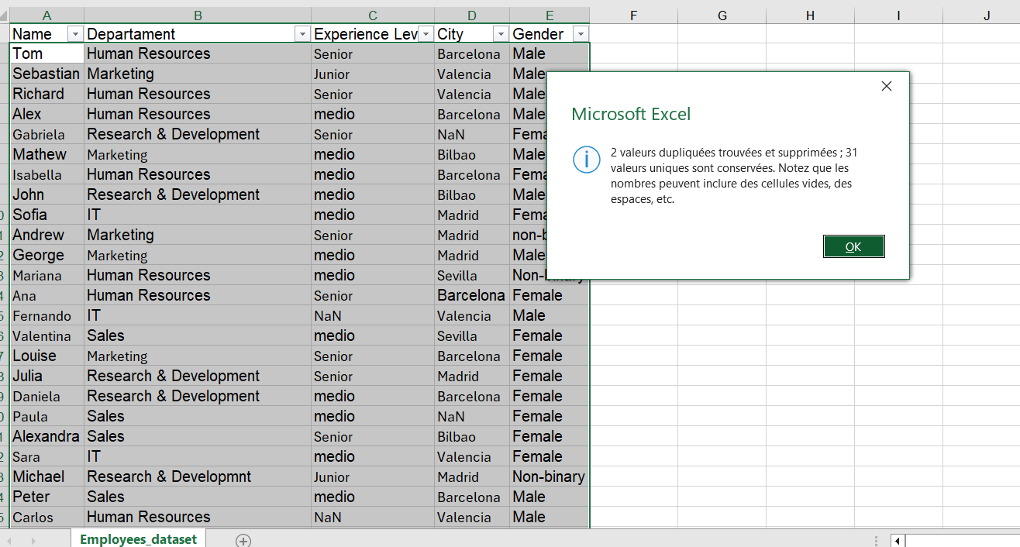

2. Clean the Data:
- Standardize Department Names:
  - Use Find and Replace (Ctrl+H) to correct any misspellings. For example:
    - "Marketin" → "Marketing"
    - "Sals" → "Sales"
    - "it" → "IT"
    - "Research & Developmnt" → "Research & Development"
  - For consistency, you can also use Excel's Text Functions like PROPER() to format text (e.g., turn "MALE" to "Male").
- Fix Experience Levels:
  - Ensure all experience levels are consistent (e.g., "medio" → "Medium" and "Senior" stays "Senior").
  - Use Find and Replace to fix these entries.
- Fix Gender:
  - Standardize gender entries (e.g., "male", "MALE", "Female", "non-binary") using Find and Replace or the PROPER() function.
- Handle Missing Data:
  - Fill any missing department values (e.g., for Gabriela) by entering "Research & Development" manually where needed.
3. Remove Duplicates:
- If you have duplicate entries for people (e.g., two "Ana"s), go to Data > Remove Duplicates, and choose the "Name" column to ensure that each person only appears once.
4. Count Occurrences:
- Count by Department:
- Use Pivot Tables to count how many people are in each department.
- Select your data range and go to Insert > Pivot Table.
- In the Pivot Table Field List:
- Drag Department to Rows.
- Drag Name to Values and set it to "Count" (you can do this by clicking the dropdown in the Value field and selecting "Value Field Settings" > "Count").
- Count by Experience Level:
- Create a second Pivot Table using the same process:
- Drag Experience Level to Rows.
- Drag Name to Values and set it to "Count".
- Count by Gender:
- Create a third Pivot Table:
- Drag Gender to Rows.
- Drag Name to Values and set it to "Count".

